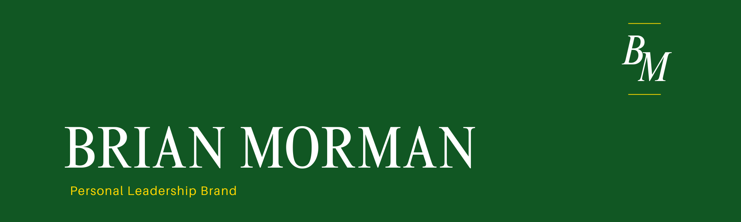
The course pack readings outline five steps to building a personal leadership brand. That brand is key to making the impressions you want to make, shaping the way you are viewed, and helping to align each person’s actions intentionally with their goals and values.

In the next year I will bring project results to the product teams I work with to deliver technical excellence for our external customers. For my team I will help create increased confidence in our organization and contribute to improved relationships with our internal Boeing customers and improve my team’s reputation within the business. Within my team I will help build

After looking through the word cloud offered in the course pack readings, I choose six words that jumped out as descriptors of myself right now: Driven, Kind, Positive, Confident, Innovative, and Productive. But much like Judy in the case study given I thought through my current personal brand in the office. I think I am known to be all the things listed above but past manager feedback has told me to focus more on analytical skill and try not to jump to decisions without enough data. For this reason, I chose the following skills as my traits I want to be known for:
Driven, Insightful, Logical, Confident, Consistent, Productive

The next step was to combine those six words into three descriptive phrases:
Logical insights, Confidently Driven, Consistent results
For me these three phrases take my current brand and skills and aim them in a more analytical direction that will create confidence in my abilities and emphasize the traits that come naturally to me.

I want to be known for possessing a confident drive to produce consistent results from logical insights so that I can become a trusted technical leader, a motivating coach, and a leader who delivers for and with my team.

I am still a new member of my team at Boeing. That means my brand is yet to be written here. I will focus on building my knowledge here and showing constant curiosity to build analytical strength and avoid haste in decision making. I’ll continue to use my emotional skill set to build relationships and to enjoy the work along the way.



